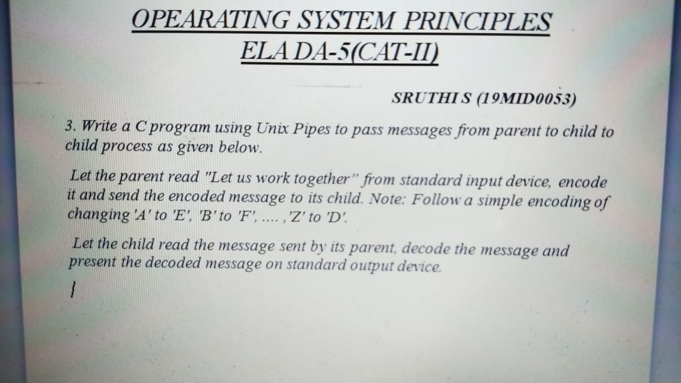

Write a C program using Unix Pipes to pass messages from parent to child process as given

below.

Let the parent read "Do not disturb me, I am busy" from standard input device, encode it and

send the encoded message to its child. Note: Follow a simple encoding of changing 'A' to 'C',

'B' to 'D', .... ,'Z' to 'B'.

Let the child read the message sent by its parent, decode the message and present the decoded

message on standard output device.